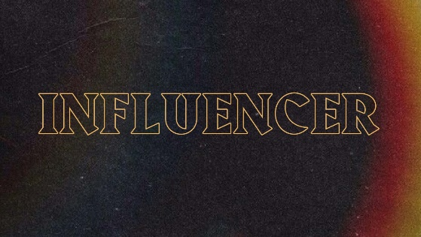**Influencer – Week 3**

**LIFE/INTRO QUESTIONS (CHOOSE 1 OR 2)**

* How long does it take for you to get ready in the morning?
* Would you rather get up later in the morning and not look the best or get up earlier to make your outer appearance look great?

**CONNECTION QUESTION**

* How often do you find yourself caring more about your outer appearance than your inner appearance?

**Sermon in a Sentence**

* Influence grows inside out.

**SCRIPTURE**

* Matthew 7:3-5 **“**Why do you see the speck that is in your brother's eye, but do not notice the log that is in your own eye? **4** Or how can you say to your brother, ‘Let me take the speck out of your eye,’ when there is the log in your own eye? **5** You hypocrite, first take the log out of your own eye, and then you will see clearly to take the speck out of your brother's eye.”
* What is Jesus saying in this scripture?

**DISCUSSION QUESTIONS**

* What negative and positive habits do you have? Share them.
* How often do you find yourself thinking you know everything? Be honest. Explain.
* If I asked you who you are, would you be able to tell me? What are your strengths, weaknesses, values, etc.?

**LIFE APPLICATION**

We want students walking away with 1 or 2 things they are going to do SOON to apply what they discussed.

* If you are not self aware already, what are some things you could do to become more self aware?
* fpStudents Instagram will be having a 60 second clip teaching you about the basics of kingdom influence so make sure you take a MINUTE out of your day to listen to it and learn something from it. Next week we will come back and each talk about something we took away from the clips.

**TAKE IT OUT**

* Close small group out with prayer requests.
* After prayer, remind them of THE WEEKEND and any upcoming group events!